DATABASE NORMALIZATION

ASSIGNMENT FOR THE DATABASE

Lecturer :
Asmunin, S.Kom., M.Kom.
Presented by :
Aisyah Currents
25091397108 / 2025I

INFORMATIC MANAGEMENT MAJOR
FACULTY OF VOCATION
UNIVERSITAS NEGERI SURABAYA
YEAR 2026

CASE 1
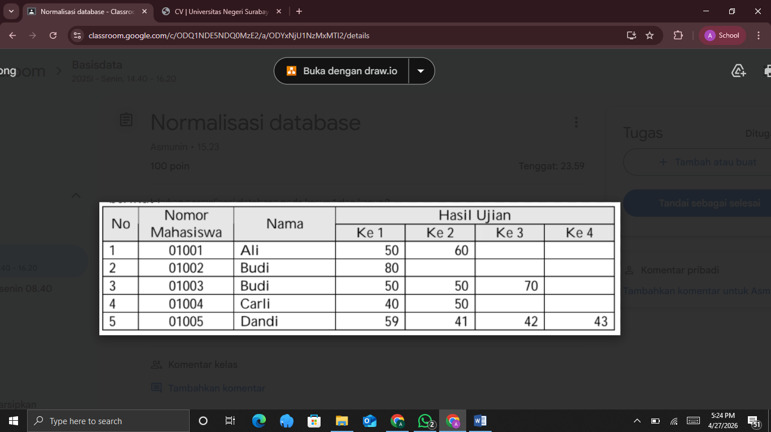
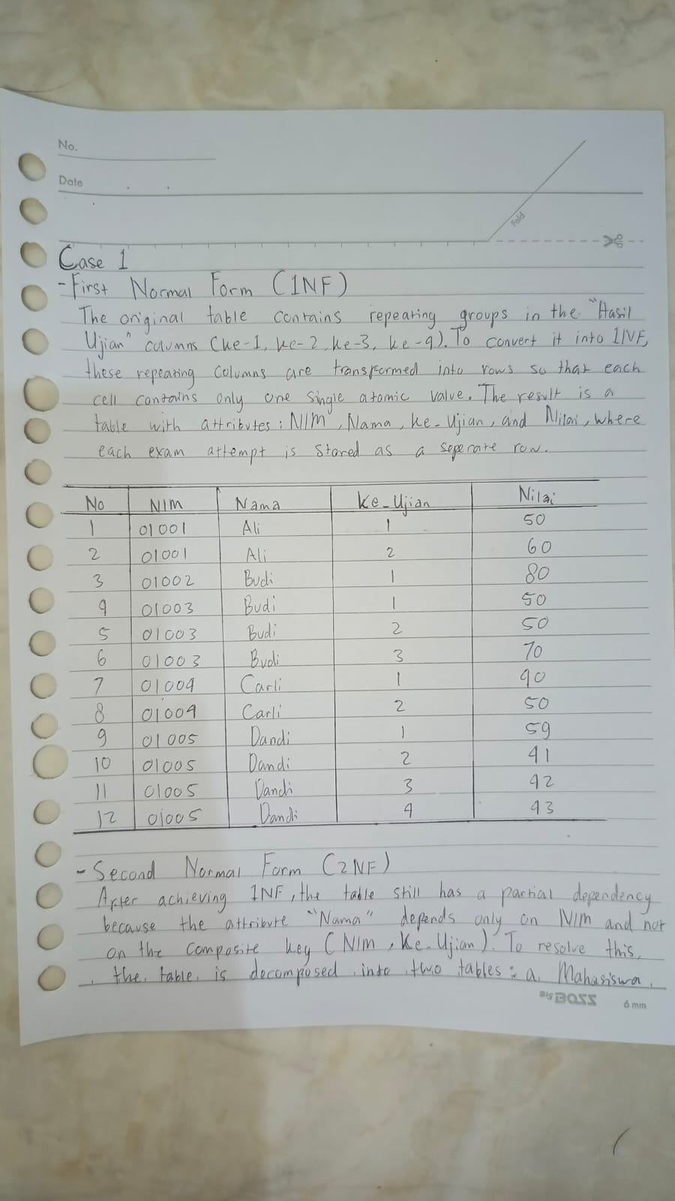
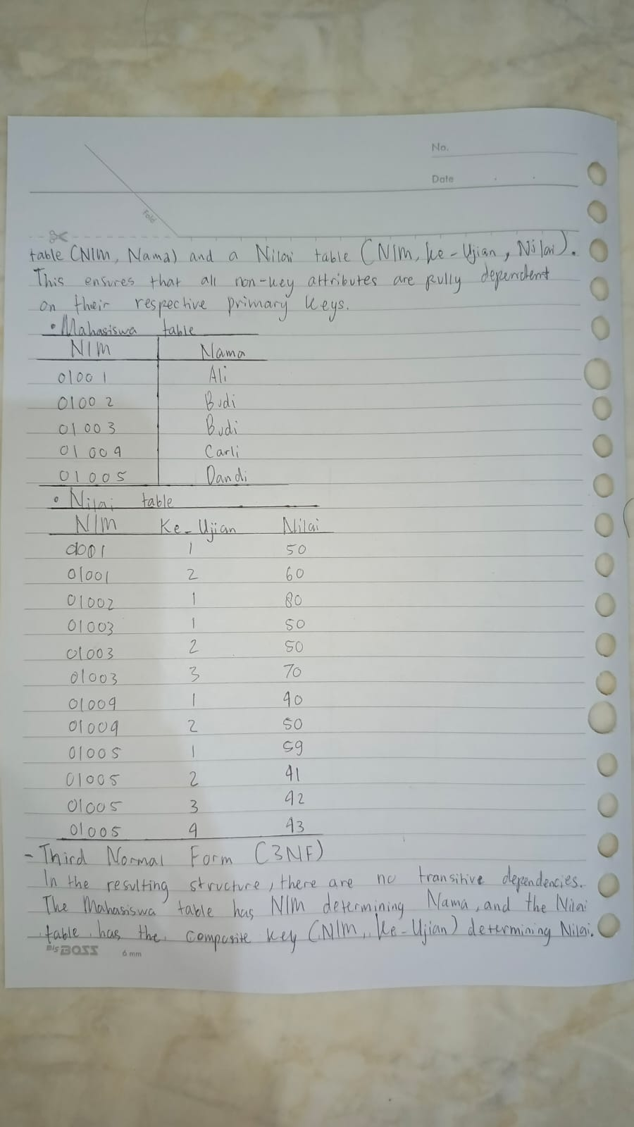
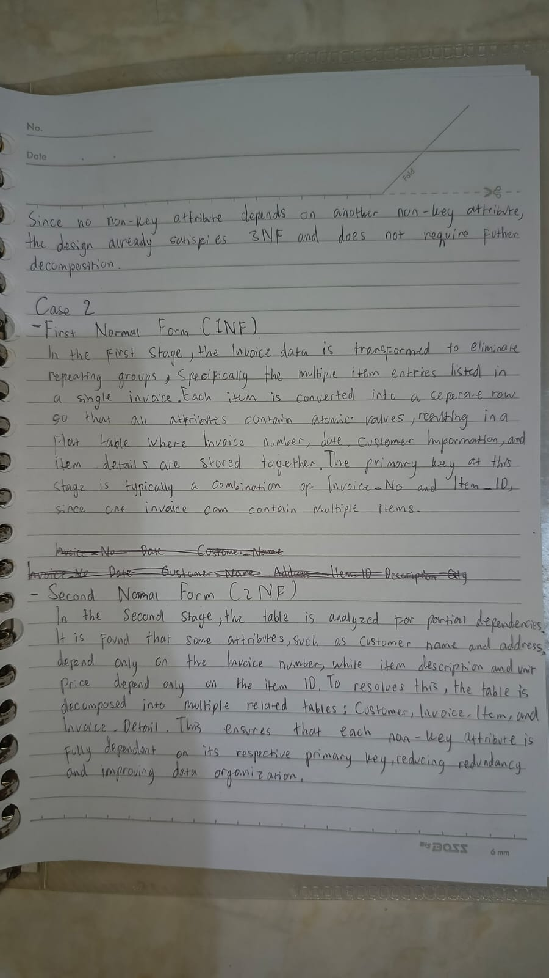

CASE 2
